1. Define a abstract class figure. Define the area and volume method in the child classes .Use dynamic method dispatch.

Solution:

CODE:

import java.util.*;

abstract class Figure {

public abstract void area();

public abstract void volume();

}

class Sphere extends Figure {

int r;

public void getRadius(){

Scanner my_input = new Scanner(System.in);

System.out.print("Enter radius of sphere : ");

r = my_input.nextInt();

}

public void area(){

System.out.println("Area of Sphere is : " + (4*Math.PI*r*r));

}

public void volume(){

System.out.println("volume of Sphere is : " + (4*Math.PI*r*r*r/3));

}

}

class Cube extends Figure{

int a;

public void getEdge(){

Scanner my_input = new Scanner(System.in);

System.out.print("Enter edge of cube : ");

a = my_input.nextInt();

}

public void area(){

System.out.println("Area of Cube is : " + (6*a*a));

}

public void volume(){

System.out.println("volume of Cube is : " + (a*a*a));

}

}

class Test{

public static void main(String[] args) {

Sphere s = new Sphere();

s.getRadius();

s.area();

s.volume();

Cube c = new Cube();

c.getEdge();

c.area();

c.volume();

}

}

OUTPUT:

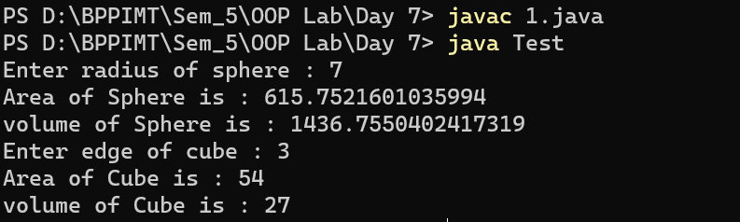

1. Implement the following design with suitable example classes.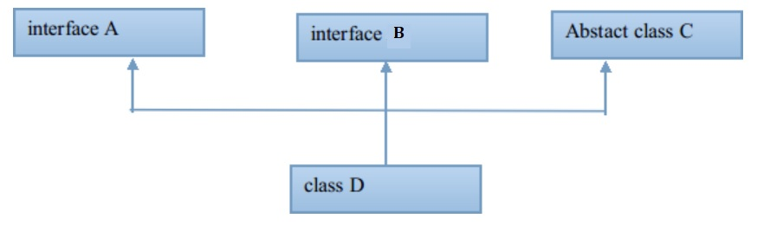

CODE:

import java.util.*;

interface FindArea{

public void area();

}

interface FindVolume{

public void volume();

}

abstract class FindRadius{

public abstract void getRadius();

}

class Sphere extends FindRadius implements FindArea, FindVolume {

int r;

public void getRadius(){

Scanner my_input = new Scanner(System.in);

System.out.print("Enter radius of sphere : ");

r = my_input.nextInt();

}

public void area(){

System.out.println("Area of Sphere is : " + (4*Math.PI*r*r));

}

public void volume(){

System.out.println("volume of Sphere is : " + (4*Math.PI*r*r*r/3));

}

}

class Test2{

public static void main(String[] args) {

Sphere s = new Sphere();

s.getRadius();

s.area();

s.volume();

}

}

OUTPUT:

